Learn more about competitive audits.

Competitive audits are one of the many valuable steps you can take during the ideation process. A **competitive audit** is an overview of your competitors’ strengths and weaknesses. Analyzing the brands and products of competitors, or the companies who offer similar products as you do, can give you a well-rounded foundation of knowledge about the market your product will enter. That knowledge will carry into your designs and help you create a product that’s helpful and unique for users. As a UX designer, you’ll likely partner with folks from other teams, like marketing or product management, to run a competitive audit.

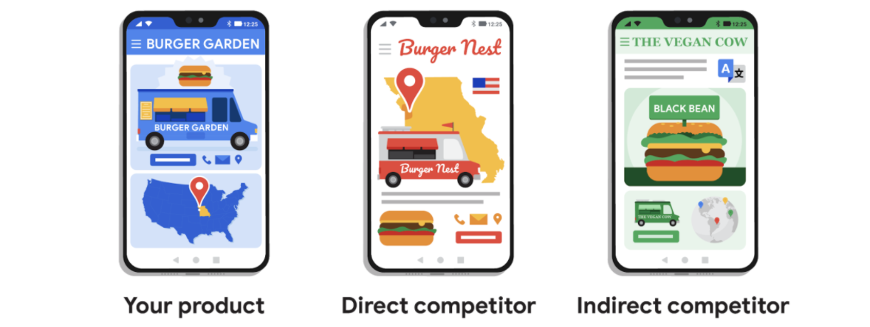

Your competition falls into two categories: direct and indirect. **Direct competitors** are companies that have offerings similar to your product and focus on the same audience. **Indirect competitors** can have a similar set of offerings and a different audience, or a different set of offerings with the same audience. Examining both of these competitors can offer insights about the path your designs might take and the users that you’re designing for.

**Why are competitive audits important?**

Consider how much work your direct and indirect competitors have already done to design and market their products to users. They’ve already had an impact on the industry that your product will enter. Studying these companies, their designs, and their user feedback is a fantastic source of information.

Competitive audits can offer many benefits throughout your ideation phase, including:

* Giving you an idea of products already in the market and their designs.
* Suggesting ideas to solve early problems that you’re facing with your own designs.
* Revealing the ways that current products in the market are not meeting users’ needs. This is a gap for your product to address!
* Demonstrating the expected life cycle of a product in the same market as yours.
* Informing all the different iterations your product could take and how those performed for your competitors.

With these benefits in mind, you can work with your team to identify the features and qualifications that you think are vital to your product. You'll focus your audit on the parts of your own design that you want to learn the most about, like the user flow through your app or the navigation within the app. A little self-reflection about the designs you're working on will set up your audit for success from the start.

**You’re ready to begin!**

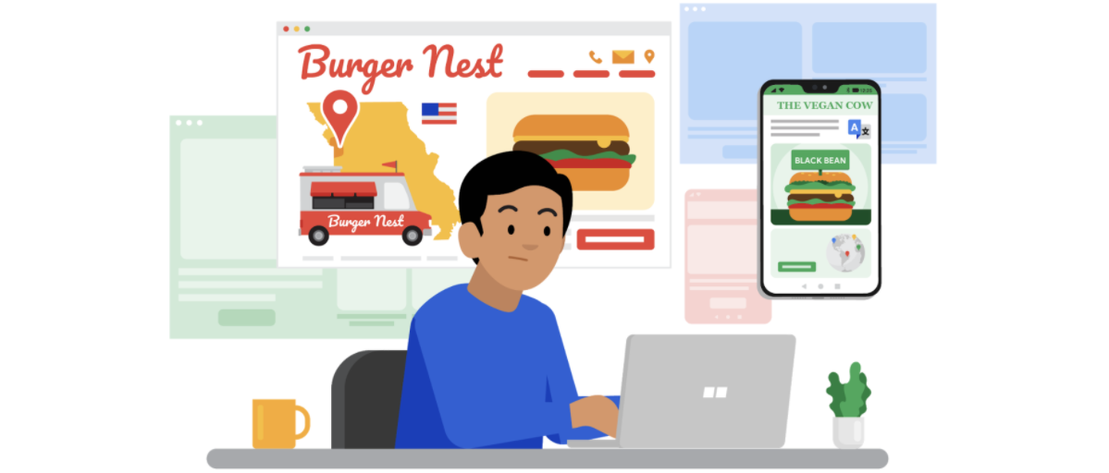

By investing time into competitive audits, your team will be able to learn from the mistakes of your competitors and can avoid making those mistakes yourselves. Think of audits as a tool to help you create something for your users that’s completely different from the competition, combining all of the strengths of your competitors’ offerings into one fantastic product!

# Want to explore competitive audits in more detail? Here are a couple of articles to help you keep digging: [A Product Designer's Guide to Competitive Analysis](https://www.toptal.com/product-managers/freelance/product-designer-guide-to-competitive-analysis) from Toptal and [How to Conduct and Prepare a Competitive Analysis](https://edwardlowe.org/how-to-conduct-and-prepare-a-competitive-analysis/) from Edward Lowe Foundation. Steps to conduct a competitive audit

You’ve already learned that conducting research on competitors is the cornerstone to understanding your product, the landscape of your industry, and your users. Completing a competitive audit is an effective way to compile all of your research into one central resource. In this reading, we’ll break down each step of the competitive audit process in more detail through an example to introduce you to the process. In a later activity, you’ll conduct your own competitive audit.

For the example in this reading, imagine you’re conducting competitive research on fast-food burger restaurants for your new client, Burger Garden. Burger Garden feels that their current website isn’t attracting much business, and they want you to help the company redesign their website.

To follow along with the example in this reading, you can use this link:

To see the completed exemplar for this course item, click the link below and select “Use Template.”

Link to exemplar: [competitor audit spreadsheet](https://docs.google.com/spreadsheets/d/161VBzpqjfF1X9hjp9E5TlbLXOuFrBS4KQsrQke8SZlk/template/preview).

**OR**

If you don’t have a Google account, you can download the exemplar directly from the attachment below.

**[Google UX Design Certificate - Competitor audit - Food trucks [example]](https://d3c33hcgiwev3.cloudfront.net/qDyTFXStQdi8kxV0rZHYpQ_17ab1870c0a04869974ec142007ae8f1_Google-UX-Design-Certificate---Competitor-audit---Food-trucks-example-.xlsx?Expires=1682726400&Signature=TYZcq944Dq2fdvGgD7ciZqv5MVq6zMgofHUFyC0h0Px94nQkjcPLiRhMPTYFtYMvqqYFzYNzh7eRdpmQuMBOohBLIBVMMqKCvW8PD6VC64ASqVBdUoWhtGSSEYTTTxojkxJJXIvf4fcxdLL5MVwQsaBnYuAsYcPXXDSiUImoJK4_&Key-Pair-Id=APKAJLTNE6QMUY6HBC5A" \t "_blank)**

[XLSX File](https://d3c33hcgiwev3.cloudfront.net/qDyTFXStQdi8kxV0rZHYpQ_17ab1870c0a04869974ec142007ae8f1_Google-UX-Design-Certificate---Competitor-audit---Food-trucks-example-.xlsx?Expires=1682726400&Signature=TYZcq944Dq2fdvGgD7ciZqv5MVq6zMgofHUFyC0h0Px94nQkjcPLiRhMPTYFtYMvqqYFzYNzh7eRdpmQuMBOohBLIBVMMqKCvW8PD6VC64ASqVBdUoWhtGSSEYTTTxojkxJJXIvf4fcxdLL5MVwQsaBnYuAsYcPXXDSiUImoJK4_&Key-Pair-Id=APKAJLTNE6QMUY6HBC5A" \t "_blank)

## Step 1. Outline the audit goals

As a UX designer, you know that the ideation process is most effective after you’ve completed an audit on your new client, Burger Garden, and their competitors. But before you move into the details of the audit, you have to define your goals. Since this project is for a website redesign, the goal of the competitive audit is to compare the user experience of each competitor’s website.

Using consistent language for rating competitor products can also create more uniform feedback and help you “grade” competitors. You can grade competitors on a scale of:

**Needs work:** The app is not usable, and users aren’t getting what they need from this aspect of the app.

**Okay:** This aspect has some issues, but with some work, it could meet user needs.

**Good:** This aspect works well, but doesn’t always provide users with the necessary information easily.

**Outstanding:** This aspect feels consistent, and it meets or exceeds the user’s needs.

## Step 2. List competitors

Start to build the competitor audit using the template. First, ask the company or team who they consider to be their direct and indirect competitors. As a reminder, **direct competitors** have offerings that are similar to your product and focus on the same audience. **Indirect competitors** either have a similar set of offerings but focus on a different audience, or they have a different set of offerings and focus on the same audience. Getting this information early can provide good insight into where the company really fits into their industry.

For example, Burger Garden mentioned that Beef Eaters restaurant is one of their direct competitors, so they should be included on the list. Based on your own research, you find two more direct competitors that are also burger restaurants in the same geographical area as Burger Garden, called Burger Nest and The Spotty Cow. You also come across an indirect competitor, The Vegan Cow, that has an international presence and really appealing imagery on their website. The competitor audit spreadsheet now includes the information shown below.

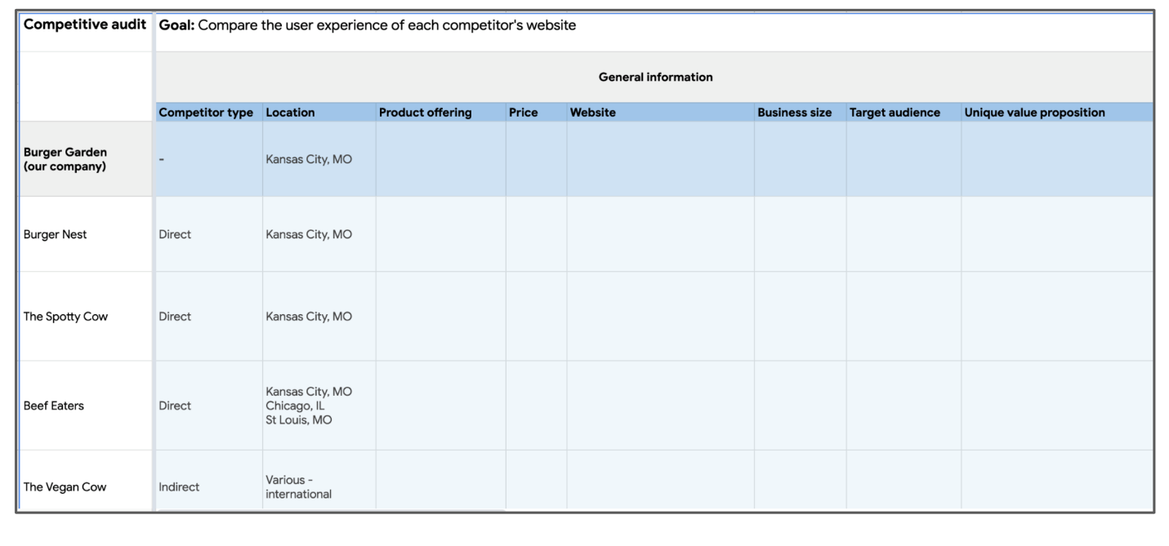

## Step 3. Determine the specific competitor aspects you want to compare

Defining a list of aspects you want to compare makes it easier to compile your results for analysis later on in the process. For this example, imagine that you check out each of the competitors’ websites and rate them based on the following categories:

* **First impressions:** Check out the website on both desktop and mobile devices, and make note of your first impressions. Is the website responsive, meaning that it resizes across devices? Does the design complement the product? How do you feel about the website?
* **Interaction:** Explore the user flow and navigation of the website. What features are available for users? Is the website accessible to all users, including those using screen readers? How inclusive is their website to non-English speakers? Will the user get confused as they click through the website pages, or is the navigation clear?
* **Visual design:** Review competitor branding and their overall consistency. Does the website appear and feel the same throughout all sections and pages? Does the branding match the intended audience? Is the imagery and color palette memorable?
* **Content:** Examine the written content included on the website. Does the tone of the content match the company’s branding? Will users be able to find the details they’re interested in?

These are the aspects to list across the top row of the competitor audit. In the example spreadsheet, these aspects are listed in rows 3 and 4. This means you would fill in information about these aspects for each of the companies you’re evaluating.

## Step 4. Research each company

Now that the list of competitors and features to compare is filled in, it’s time to check out each of Burger Garden’s competitors and start the audit. If you were conducting your own audit, you would fill out the spreadsheet row-by-row as you review each competitor. You can include notes in bullet point form, links, and screenshots—whatever is most helpful for your information gathering process! Let’s check out each section of the example spreadsheet.

### Audience

Millennials, including families, make up the biggest portion of the competitors’ audiences. There’s also a small crossover between millennials and Gen-Z college students. This is very similar to the audience that Burger Garden is targeting. Only one competitor, The Vegan Cow, has a different audience. That’s okay! The Vegan Cow wasn’t included as a direct competitor because their audience isn’t similar to Burger Garden’s. It’s still important to compare their website and overall user experience to ensure you’re getting a good sense of the entire market.

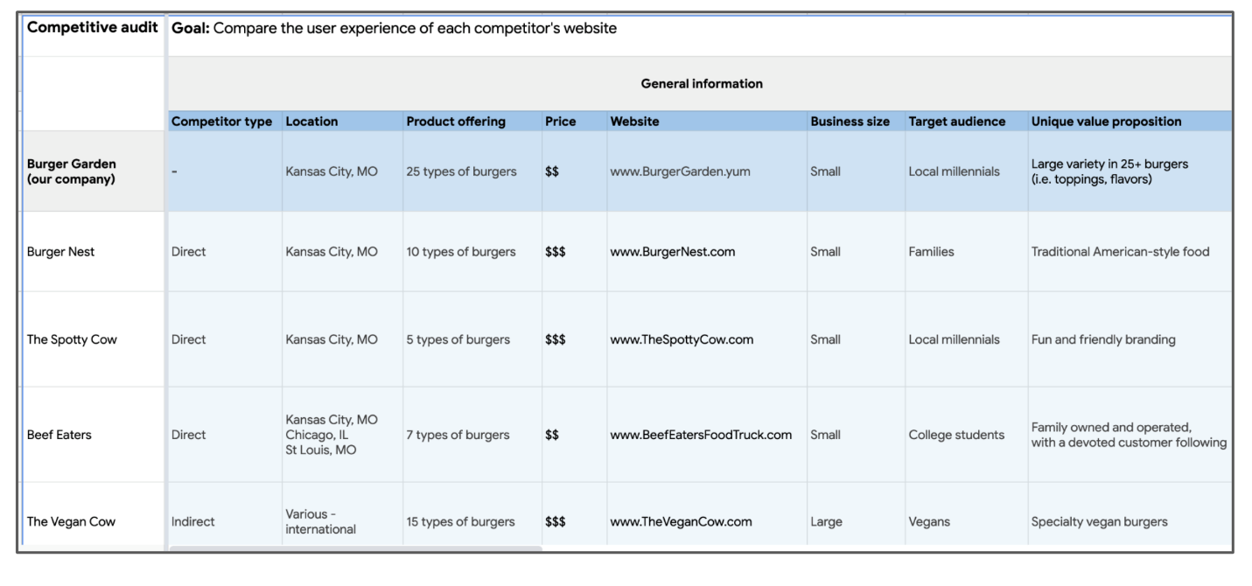

### First impressions

The websites that make the best first impression are The Spotty Cow and The Vegan Cow. Both provide appealing and clear imagery and are fully responsive websites. On the other end, the websites for Beef Eaters and Burger Nest weren’t very impressive. While they’re easy to navigate, they both need to work on improving their layouts.

For the mobile website experience, only one site had issues with responsiveness: Beef Eaters. Their website didn’t adjust to the smaller screen size of a mobile phone, so the spacing was misaligned and some information was cut off.

For the sites with lower ratings, the biggest issue was the menu. Sometimes the menu wasn’t accessible, and other times the menu was included as an image that was hard to read. That’s definitely something to make note of for your redesign of the Burger Garden website!

### Interaction

The next part of the competitive audit focuses on the user’s ability to quickly and efficiently find what they’re searching for on the website. Your client, Burger Garden, needs help to create a hierarchy for their site that’s easier for users to follow and interact with.

The Spotty Cow’s website includes animations that slow the navigation, and The Burger Nest’s site has lots of unnecessary content on the homepage, which makes it hard to find important information like their phone number and menu. On the other end of the spectrum, the websites that work well have a clear navigation style and make it obvious which elements are clickable and which aren’t—a characteristic that’s important to include in the redesign of Burger Garden’s website. The Vegan Cow is the standout competitor in the category with useful features like a store locator and comprehensive accessibility considerations including multiple language options and compatibility with screen reader technologies.

### Visual design

A website with clear and consistent visual design is a great way to draw users into a product and company. Burger Garden’s current website has pretty solid visual design overall, but there are a few areas that could be updated to better reflect their brand tone.

The Spotty Cow and The Vegan Cow communicate their brand well with distinct colors, typography, and photography. But Burger Nest and Beef Eaters both have an inconsistent visual style on their websites, and Burger Nest’s site doesn’t communicate their brand very well.

### Content

The tone of the content is another way to communicate a company’s brand and engage users. Most of Burger Garden’s competitors use an engaging and fun tone that fits their audiences. Burger Garden’s tone is a little inconsistent and not as light-hearted as its competitors. This is an area for improvement when you redesign their website!

In general, the competitors’ content is short and easy to follow. Burger Garden’s current website descriptions come off as a bit dry and overly long, so you can point to competitors’ content as an example to follow.

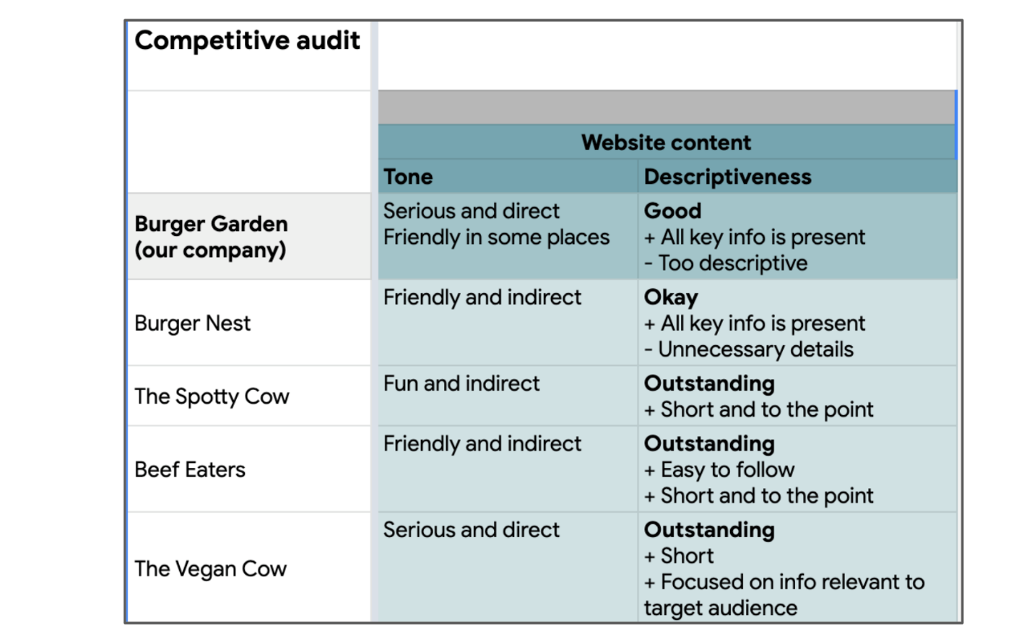

## Step 5. Summarize your findings in a report.

After conducting research, gathering data, and analyzing your findings, summarize your work in a report. What you include in your report and how you present your findings will vary depending on the audit goals you outlined at the beginning of the process. For example, if your audit mainly focuses on comparing competitors’ audiences, you might want to include a few informational graphics with numbers and figures. Or, if your audit mainly focuses on visual design, you might want to include screenshots of your competitors’ websites with different areas highlighted. You’ll learn how to create a report summarizing your research findings in more detail later on in the program, so don’t worry too much about it right now!

## Completing your audit

# Conducting a competitive audit is a great way to familiarize yourself with user experience design by getting more information about a new industry, a new client, and recent industry trends. The information you learn can be used throughout the design process. If you can, it’s best to take your time with the competitive audit process so you’ll have a great foundation of knowledge to build your designs on moving forward. Good luck! How to present a competitive audit

After researching direct and indirect competitors, and compiling those findings into a spreadsheet, the next step is sharing your insights with your team or client.

You can present your competitive audit as a written report or a slideshow presentation using software like Google Slides, Microsoft PowerPoint, or Apple’s Keynote. This course will teach you how to present your audit findings as a written report, but in the workplace you can choose from many different formats to demonstrate what you’ve learned to stakeholders. In this reading, you’ll learn about some best practices for creating a slideshow presentation of your competitive audit findings.

Both written reports and slideshow presentations have their advantages. Slideshows are dynamic and visually engaging, but require more time and effort to create and rehearse. Written reports are more concise and less time-consuming to create. They’re an efficient way to communicate insights quickly when your audience doesn’t have a lot of time.

Later in the course, you’ll prepare to present a competitive audit for your portfolio project. You’ll learn more about written reports when you get there. Right now, let's explore some best practices for  presenting competitive audit findings as a slideshow presentation. Ready to learn more? Here we go!

**Tips for your slides and presentation structure**

Every good presentation needs an introduction, so you’ll want to begin by laying out the goals of your competitive audit. It’s also a good idea to outline your research questions, methodology, and  the features or characteristics you compared across competitors. Summarizing the purpose of your presentation makes it clear exactly what you're trying to learn about the competition. Note that the example introductory slide below includes sections for an objective, research questions, and procedures.

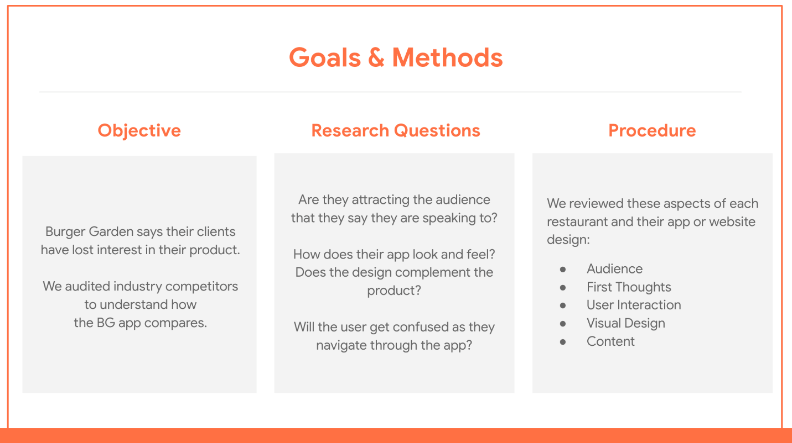Slide that shows goals and methods, broken into Objective, Research Questions, and Procedure. Objective: Burger Garden says their clients have lost interest in their product. We audited industry competitors to understand how the BG app compares. Research Questions: Are they attracting the right audience that they say they are speaking to? How does their app look and feel? Does the design complement the product? Will the user get confused as they navigate through the app? Procedure: We reviewed these aspects of each restaurant and their app or website design: Audience, First Thoughts, User Interaction, Visual Design, and Content.

To organize your information for your audience, begin each section of your presentation with a slide that identifies the section’s topic (similar to a chapter title in a book). Stick to simple, clear visuals, like the bold text and solid background of the slide below:



Next, summarize what you learned about your competitors’ products, and how they compare to yours. Be sure to point out where your product excels, as well as areas that need improvement.

As you organize your presentation, think about the most effective ways to present your insights. Keep the overall design as simple and clean as possible. Avoiding cluttered and confusing imagery makes it easier for your audience to follow along and focus on the important information. Note how the example slide below outlines  the most important information and expands on it  in the section to the left:

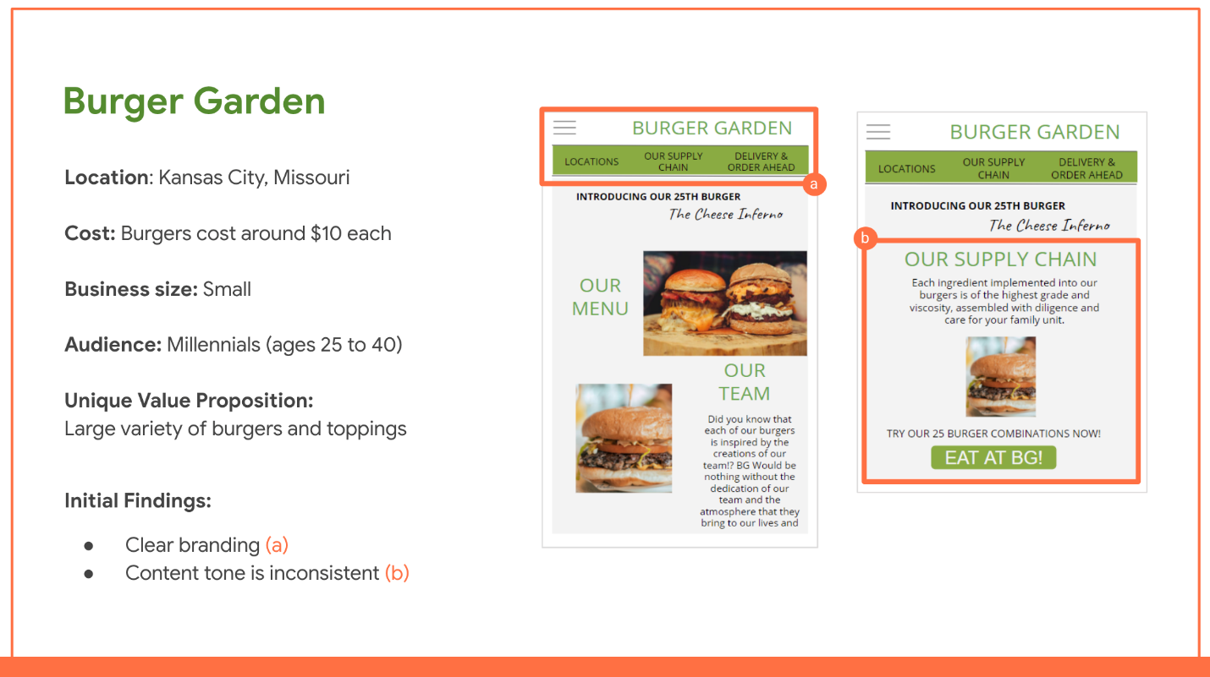Visual presentation of competitive audit findings for Burger Garden located in Kansas City, Missouri. On the left of the presentation slide, text shows the cost of burgers (around $10 each), the business size (small), the audience (millennials), the unique value prop (large variety of burgers and toppings), and the initial findings (clear branding identified in screenshot A, content ton is inconsistent in screenshot B). On the right side of the slides are two screenshots. Screenshot A shows the company name is clearly displayed at the top of their website. Screenshot B shows text on the website that reads "Each ingredient implemented into our burgers is of the highest grade and viscosity, assembled with diligence and care for your family unit."

Finally, conclude your presentation with  a summary of key points and takeaways. As you learned earlier, competitive audits can compare up to 10 companies. That’s a lot of information for your audience to take in! A summary can refresh their memories by recapping the most important information.

**Presenting data effectively**

The way you present your data can influence how your audience interprets it. Keep in mind that different types of data lend themselves to different formats. For example, if your presentation has a lot of numbers or quantitative data, a chart or graph can help your audience grasp how the numbers compare to one another. To demonstrate a specific function or issue with a competitor’s product, consider including a screen recording in your presentation. Finally, it can be helpful to include a rubric that explains the grading system you used in your audit. For example, the rubric system used in the example audit graded the burger restaurants from “needs work” to “outstanding.” Using that rubric, each restaurant was rated on a scale of one to four in each category to create a final rating.

**Delivering a strong presentation**

Knowing what  to include in your presentation is only part of the process. As you prepare to present your findings, keep these tips for effective presentations in mind:

* **Get feedback from your team.** Share your report or slides with a trusted teammate ahead of time to get their take on how the information flows.
* **Limit the amount of text on your slides.** Your slides should include just enough information to draw attention to important points. Save the details for your speech.
* **Stick to the highlights.** A presentation to your team or client should only focus on the highlights of your audit. If you want to get into more detail, add them to the appendix of your presentation or create a written report.
* **Use notes.** An outline or note cards can help you stay focused, on topic, and on time.
* **Practice ahead of time.** Do a few trial runs before the big day to get comfortable with the content and pace of your presentation.
* **Use relevant graphics.** Make sure any images and graphics relate directly to the topic of your presentation. Choose images and graphics carefully to ensure they enhance clarity.
* **Keep your biases in check.** Be aware of your own design biases and try to prevent them from clouding your judgment during the presentation.
* **Be able to defend your conclusions.** Make sure you have evidence to back up your conclusions. Use actual data and specific examples whenever possible.

Presenting your research can seem intimidating, but remember that you are representing your users! Competitive audits give you, your team, and your clients knowledge that will help create well-rounded product designs that work. To ease your presentation jitters, check out  this article from Forbes for expert tips on connecting with your audience: [20 World-Class Presentation Experts Share Their Top Tips](https://www.forbes.com/sites/markfidelman/2014/08/15/20-world-class-presentation-experts-share-their-top-tips/?sh=2920b075c40d).